ASSIGNMENT 5
Create, Alter

In this lab you will use SQL statements that fall in both the DDL and DML category. In the previous labs you were retrieving information that was already stored in the database. In this lab you will be storing new information in the database.

You must execute the statements in the order in which the questions are being asked.

Suggestions:
- Do not create a spool file. This lab will probably take several days. Since you cannot guarantee that the work that you did on my home computer or the lab computers on campus will be there the next time you open up the SQLPlus session, I would make the following suggestion: Store all your SQL statements in a text file. Then you can just copy and paste your SQL statements into the SQLPlus session and get back to where you left off.

- I would also suggest that you drop all your tables in the beginning of the text file just in case the tables are still there so that you don’t get any error messages

All the tables that you create should be prefixed with the first five letters of your lastname such as sabze_patient

What to turn in:
- You will turn in this word document only. I do not want any other files
- Paste a printscreen of either the SQLPlus session or SQL Developer showing only the SQL command and the results from the database engine. Some of the SQL statements that you issue may cause an error and may actually be the expected result. Do not assume that just because you are not getting an error message, everything is okay.
- When typing in your SQL statements, make sure that the keywords are all in uppercase. The identifiers that you come up with such as table names, column names or constraint names should all be in lower case.
- Make sure that you prefix your table names with the first five letters of your last name.
- Make sure that you only provide a printscreen of the snippet that pertains to the question (NOTHING MORE).

Suggestion: you can use the snipping tool in windows 7 or you can download this open source program http://getgreenshot.org/ for printscreens. Provide only the printscreen that pertains to the question. I do not want to see your trial and errors or things that pertain to other questions.

SQLPlus or SQLDeveloper (Your choice)
Example | Display the contents of the dual table
 | 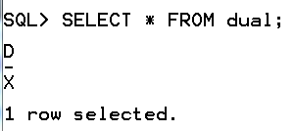 OR 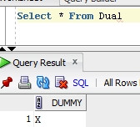
Next Example | Create a table called test
 | 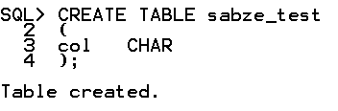 OR 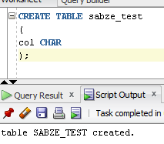

All the tables that you create must be prefixed with the first five letters of your last name such as sabze_student.

1A | Create a student table that will hold the following data. Make sure you assign a primary key.  SSN text  lname text  fname text  age numeric  salary numeric  dob numeric
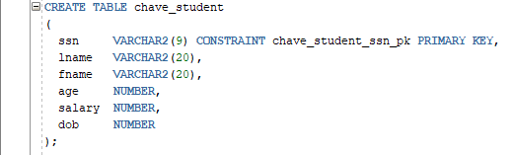
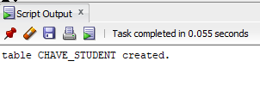

1B | After the table has been created add a candidate key based on lname and fname.  Note: Candidate and unique key are the same thing
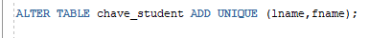
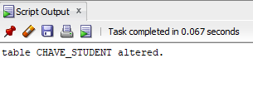

1C | After the table has been created add a check constraint such that the age is greater than 10 but less than 50. Provide a name for the check constraint.
 | 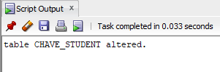
1D | After the table has been created add a column called address.
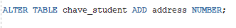
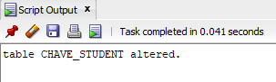

1E | After the table has been created, modify the dob column to be of datatype date and also not null
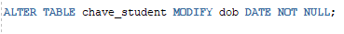
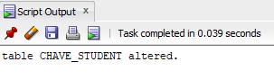

1F | Create a composite index on ssn and dob
 | 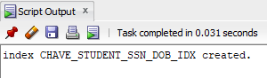
1G | After the table has been created add a column called transferable with a not null constraint. Do not assign a name to the constraint
 | 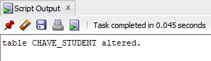
1H | After the table has been created add a check constraint on the column transferable to allow only ‘y’,’Y’,’n’,’N’. Give the constraint a name.
 | 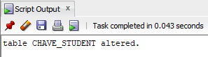
1I | Drop the age column
 | 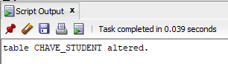

2A | Create a second table called class that will hold the following data. You decide what the data types are going to be.  Class code  Class description  In the create table statement make Class description the candidate key and also make it is not null. NOTE: Candidate and unique keys are the same thing
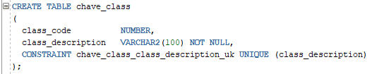
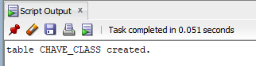

2B | After the table has been created add the primary key. Give the constraint a name
 | 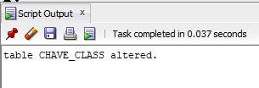
2C | Create an index on class description
 | 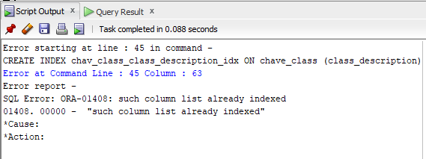

3A | Create a third table called student_class. This table is an association table that contains information on the different class that the students are taking. You figure out what the columns should be. It should contain only two columns.
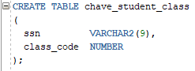
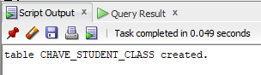

3B | After the table has been created add the primary key constraint (Name the constraint)
 | 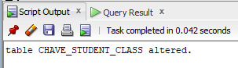
3C | After the table has been created add the foreign key constraint(s) (Name the constraint(s))
